Table of Contents

Introduction 2

Myths of Topic 3

Background and Purpose of Paper 4

Experiment 4

Methods 5

Materials 5

Procedures and Measures 6

Results 6

Replicate of Experimental Plot 7

Discussion 12

Interpretation of Findings 12

Contributions to the Field of Health 13

Issues, Challenges, Limitations 14

Issues 14

Limitations 15

Challenges 15

References 17

Appendix 18

Appendix 1 - Definition of Key Terms 18

Appendix 2 - Growth Rate Measurements 18

Appendix 3 - MIC Measurements 19

Appendix 4 – Competition Experiments 19

Appendix 5 - Enrichment of Do Novo Evolved Resistant Mutants 20

Appendix 6 - Selection Coefficient Representation 20

# Introduction

Bacteria are single-celled microscopic living organisms that can be found plentiful on Earth - from the soil, rock, oceans and even in snow (Microbiology Society, 2016). Some bacteria live in or on other organisms such as plants, animals and humans. Some bacteria are useful - they play an important role ecological recycling[1] and decomposition. However, some are dangerous and threatening - they act as parasites or pathogens to cause disease and infection, food spoilage and crop damage.

Bacteria can be classified into two groups and they are, Gram-positive and Gram-negative. A Gram test - adding a violet dye to the bacteria - is used to differentiate bacterial species. Gram-positive bacteria will retain the Gram test colour of the dye, while Gram-negative bacteria will not. They will be coloured red or pink instead.

Antibiotics are chemicals that are used to kill or inhibit the growth of bacteria. They are used to treat bacterial infections (Microbiology Society, 2016).

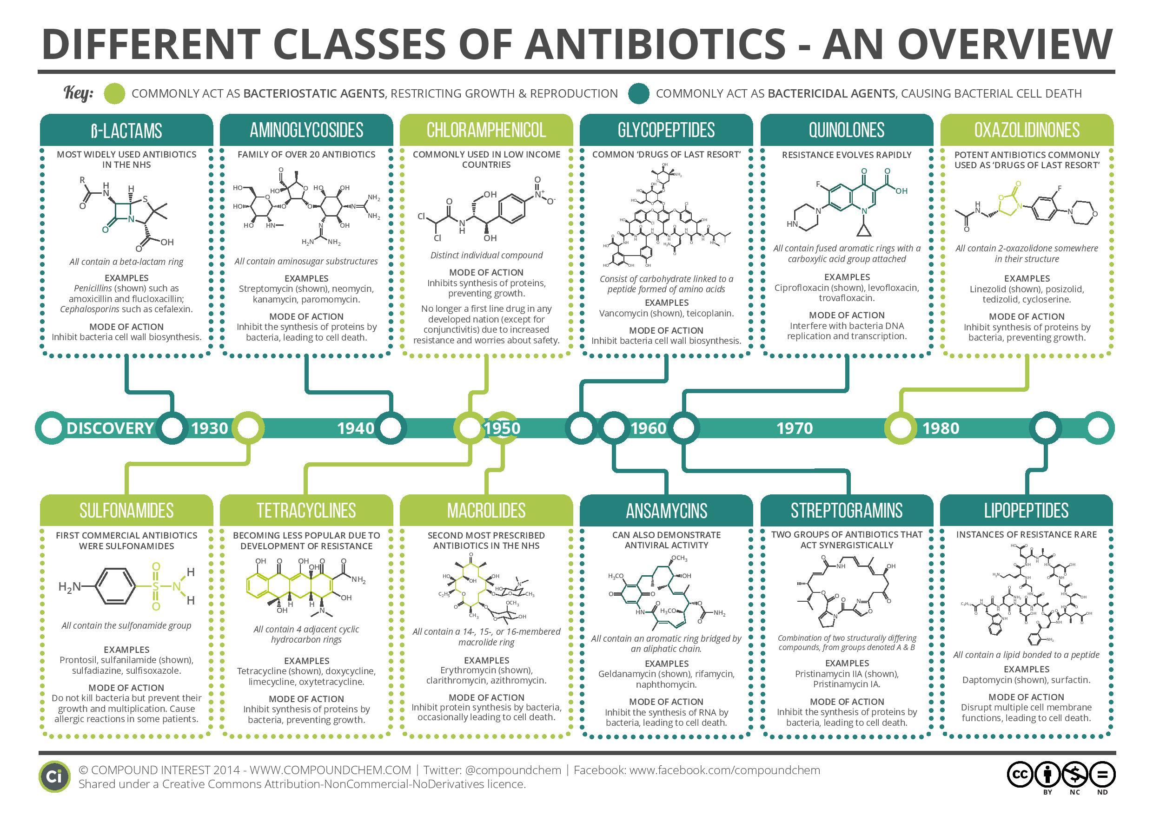

Figure 1. Different classes of antibiotics

Antibiotics can be classified according to their chemical structure or according to the range of pathogens against which it is effective. As according to Figure 1 above, antibiotics can be split into two classes - bactericidal antibiotics and bactericidal antibodies (Compound Interest, 2014). Bactericidal antibiotics kill bacteria by prevent the bacteria from synthesizing its cell wall while bacteriostatic antibiotics kill bacteria by inhibiting the growth or reproduction of the bacterial enzymes or protein translation (Boundless, 2016).

Antibiotic resistance has become a major problem in healthcare. Antibiotic resistance means that the antibiotic has lost its ability to effectively control or kill the bacterial growth - The bacteria is "resistant" and will continue to multiply in the presence of therapeutic levels of an antibiotic. This is largely due to the enrichment and spread of highly resistant bacteria due to the onset of extensive use and misuse of antibiotics resulted from human activity. This will lead to dire consequences; if no progress is made to create a stronger antibiotic in order to stop the bacterial growth or spread.

An antibiotic-resistant bacterial infection will result in:

* A longer, persistent bacterial infection
* A higher likelihood of complications from the infection
* A persistent bacteria, which remain infectious for longer period of time, and pass the infection elsewhere, and escalates the problem

## Myths of Topic

It is known that high concentrations of antibiotics can select for resistant mutants. However, it still remains unclear how effective low antibiotic concentrations are in selecting of resistant mutants. In pharmacodynamic models[2], it is assumed that selection of resistant bacteria occurs at concentrations between the minimal inhibitory concentration (MIC)[3] of the susceptible wild type population (MICsusc) and that of the resistant bacteria (MICres) - as shown in figure 2, dark orange region. Thus, antibiotic concentrations below the MICsusc will not affect the growth of bacteria - It will not select for resistant mutants.

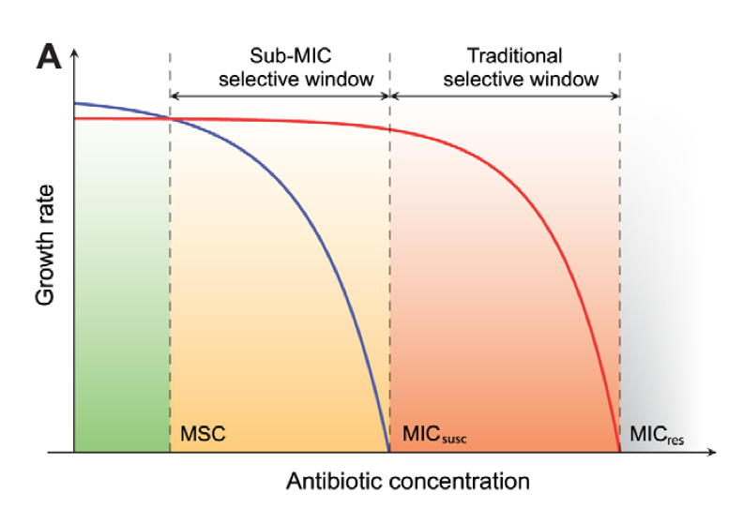

Figure 2. Growth rate as a function of antibiotic concentration

The paper, on the other hand, proves that in low antibiotic concentrations, such as those present in natural environments or in humans as well as animal body compartments during therapeutic or growth promotion use, selection of resistant mutants can still exists. Hence, low antibiotic concentrations between MSC and MICsusc concentration, as shown in figure 2, light orange region, does not necessarily inhibit the selection and enrichment of resistant mutants.

## Background and Purpose of Paper

Antibiotic resistance has become a major healthcare problem in the world today. It arose due to the extensive use and misuse of antibiotics. However, it still remains unclear where most of the resistant bacteria have been selected, and whether or not if the low antibiotic concentrations that are present in natural environments or in humans and animal body compartments during therapeutic or growth promotion use, are a factor when selecting and enriching of resistant mutants. The data and information provided in the paper proves that certain antibiotics maintained in extremely low concentrations (e.g. similar to the concentrations found in natural environments) could select for resistant bacteria. Thus, it is possible to suggest that antibiotic release into the environment could contribute to the emergence and maintenance of resistance of bacteria. It is then important to introduce measures to reduce antibiotic pollution (in the environment).

# Experiment

The authors have conducted experiments to test for the selection and enrichment of resistant bacteria in low antibiotic concentrations. This section will look at the methods, materials and procedures of the experiment and the summary of the results.

## Methods

From the paper, the authors have chosen to conduct highly sensitive competition experiments between isogenic strains[4] of susceptible and resistant strains to show whether bacteria resistance can be selected at low antibiotic concentration (e.g. below the minimal inhibitory concentration). In order to ensure the consistency of the results, competition experiments are used. In addition, it is easier to increase the sensitivity of the assays and allow detection of extremely small differences in growth rates (in competition experiments).

The authors examined how far below the MICsusc concentration will the preexisting and de novo[5] generated resistant mutants be selectively enriched.

## Materials

In the context of this report, 3 antibiotics and 2 bacteria is selected for the experiment.

The 3 antibiotics are as followed (eMedExpert, 2015):

* **Tetracycline**: They are derived from a species of Streptomyces bacteria. Tetracycline antibiotic are broad-spectrum bacteriostatic agents and work by inhibiting the bacterial protein synthesis.
* **Fluoroquinolones**: Fluoroquinolones are synthetic antibiotic, and are not derived from bacteria. They inhibit the growth of bacteria by interfering with their ability to make DNA. This will thus affect the bacteria’s ability to multiply.
* **Aminoglycosides**: Aminoglycosides are derived from various species of Streptomyces. They are bactericidal and work by stopping the bacteria from making proteins. Aminoglycoside antibiotic are used to treat infections caused by gram-negative bacteria. They can be used along with penicillins or cephalosporins.

The 2 bacteria strains are as followed (APEC Water, 2016):

* **Escherichia Coli**: E-coli is a bacterium that is able to live in the intestines without causing harm to the host. However, several strains of E-coli can cause food poisoning and cause health problems such as hemorrhage. People get in contact with E-coli by eating food that have not been properly processed or harvested.
* **Salmonella Enterica**: Salmonella is a bacterium that results in food poisoning in humans and animals. Salmonella is spread through ingesting foods that are contaminated by salmonella such as raw poultry products, fruits, vegetables, and contaminated water. Contamination takes place when these foods come into contact with animal or human feces or food that are not cooked properly.

Strains used in this study were derived from Escherichia coli MG1655 and Salmonella enterica serovar Typhimurium LT2. The resistant strains were then constructed by P22 transduction (S typhimurium) or P1 transduction (E coli) of the resistance genes into the parental strains.

The resistance markers[6] used were Tn10dTet (confers tetracycline resistance), gyrA (S83L and D87N), DmarR, and DacrR mutations (confer ciprofloxacin resistance) and rpsL (K42R) (confers streptomycin resistance), all of which are found in clinical isolates of several different bacterial species.

## Procedures and Measures

Single cultures where a susceptible wild-type and a resistant strain mutant carrying different resistance markers were grown separately in the presence of different concentrations of different antibiotics. The strains were then competed for up to 80 generations by serial passage in batch cultures in the presence of different resistant markers and different concentrations of either one of the antibiotic tetracycline, ciprofloxacin (a fluoroquinolone) and streptomycin (an aminoglycoside) as well as in the absence of antibiotics.

From the experiment, the following benchmarks are measured:

* The growth rates of the bacteria strains over the generation of growth
* The ratio of resistant:susceptible strain changes as a function of the number of generations of growth at different concentrations of antibiotic

Appendix 2, 3, 4 and 5 can be referenced to, for further understanding and greater clarity in the measurements of growth rates and MIC rates, and procedures of the experiment.

## Results

The findings of the experiments are summarised as followed:

1. At concentrations far below MICsusc, the exponential growth rate of the susceptible strain was reduced without any apparent effect on the resistant strain. This suggests that the resistant strains are strongly selected at these low concentrations.
2. Fitness cost, which is usually the reduced competitive ability of bacteria resulting in lowered growth rate, of the resistance strain is balanced by the antibiotic-conferred selection for the resistant mutant.
3. Selection coefficients are independent of the initial frequency of resistant mutants. Hence, there is same enrichment of the resistant bacteria strain mutants regardless of initial frequency. References can be made to Appendix 6 for references to charts.
4. At low level of antibiotic concentration, rapid enrichment of de novo resistant mutants is observed. This means low level of antibiotic concentration give rises to new resistant mutant bacteria from the existing susceptible bacteria.
5. At sub-MIC levels of antibiotics, most pronounced for fluoroquinolones, bacterial mutation rates is shown to increase, which could potentially reduce the waiting time and thereby increase the rate of mutant take-over in a susceptible population.

Yet, the experiment’s biggest finding from this experiment is the obtainment of the formula to calculate the time it takes for de novo mutants to take over a susceptible population at low antibiotic concentration.

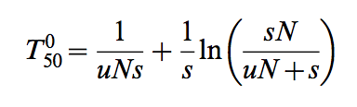

, where u = mutation rate of bacteria, N = population size of bacteria, s = fitness advantage of antibiotics, determined by the different concentration of antibiotics, T = stochastic waiting time for first mutant to appear

## Replicate of Experimental Plot

Using the data provided in the doc file (journal.ppat.1002158.s003.docx) provided together with the research paper, we have decided to replicate Figure 1B, Figure 2B as well as Figure 2D. We have uploaded the doc file, the csv files, Rmd as well as md files in our Github folder (link below).

We first created our own csv file with the relevant data inputs that we require. After which, we then replicated the experimental plot using R Studios in R (using ggplot). Our experimental plots are as shown below. They can also be viewed here in our Github folder:

[**https://github.com/aliciasoh/Project/tree/master/Replicate%20Of%20Experimental%20Plot**](https://github.com/aliciasoh/Project/tree/master/Replicate%20Of%20Experimental%20Plot)

|  |
| --- |
| The graph below shows Relative exponential growth rates of susceptible strain of S. typhimurium as a function of tetracycline concentration. Cells were grown in Mueller Hinton medium at 37uC.  The graph below shows Relative exponential growth rates of resistant strain of S. typhimurium as a function of tetracycline concentration. Cells were grown in Mueller Hinton medium at 37uC.    This is **Figure 1B** graph as seen in the paper. The graph below shows the above two graphs combined together. It shows the Relative exponential growth rates of susceptible (pink line) and resistant (green line) strains of S. typhimurium as a function of tetracycline concentration. Cells were grown in Mueller Hinton medium at 37uC.    Graph from **Figure 2B** of the paper which shows the Selection coefficients streptomycin rpsL105(K42R) vs wild type. It intercepts the X-axis at MSC = 1/4 MIC.    Graph from **Figure 2D** of the paper which shows the Selection coefficients tetracycline cobA367::Tn10dtet vs. wild type. It intercepts the X-axis at MSC = 1/100 MIC. |

# Discussion

This section will discuss these various parts: interpretation of findings, contributions the paper made to the field of health, implications to the industry, and the issues, challenges and limitations of the whole research.

## Interpretation of Findings

Antibiotic concentrations in natural environments can vary extensively. Environments where there are low antibiotic concentrations, maintenance and selection of resistant bacteria can still occur. This is explained at Results 4 and 5 (above) where at low level of antibiotic concentration, bacteria enrichment can still take place due to sub-MIC selective effects. In addition, from result 3, it suggests that low antibiotic concentration does not necessarily translate to low resistant mutants. It is the selection criteria and environment that will determine the selection.

From the formula, we can interpret that takeover time in terms of number of generations. With fixed mutation rate and fixed population, given bacteria with high antibiotic concentration, changes to resistance bacteria from susceptible ones tend to be slow, and it will take more than 1000 generations for mutation to be completed. However, given bacteria with low antibiotic concentration, resistant bacteria tend to take over the entire population easily in 100 to 1000 generations. Hence, it is suggested that low antibiotic concentration can actually give rise to resistant bacteria mutants more easily.

From Result 5, the experimenter noted that at low fluoroquinolones concentration, bacteria have a faster mutation rate. This is linked to the chemical nature of fluoroquinolones where the rate of bacteria killing is directly correlated to the level on the concentration. Hence, in low fluoroquinolones concentration, the antibiotic is more vulnerable and susceptible bacteria are more likely to mutate and take over the population faster.

## Contributions to the Field of Health

The paper has pointed out several important conclusions that could contribute in the field of health:

Firstly, antibiotic pollution caused by humans to the environment may cause the emergence and maintenance of resistant mutants. With foreign antibiotics introduced to the environment, it allows existing bacteria present in the environment to slowly gain resistance. This emphasizes the importance of introducing measures to reduce antibiotic pollution.

Secondly, at very low antibiotic levels, which are present in many natural environments or generated in certain body compartments during treatment, are contributing factors for the enrichment and maintenance of pre-existing resistant mutants as well as for the de novo selection of new mutants. This occurs due to differences in growth rate at the particular antibiotic concentration between cells with different tolerance levels to the antibiotic. Resistant mutants selected at low antibiotic concentrations are generally more fit than those selected at high concentrations.

Thirdly, it is essential for the use of treatment dosing regimens[7] that preclude prolonged time periods of sub-MIC levels of antibiotics. The two most straight-forward interventions are either to isolate antibiotics at the source (e.g. by urine separation in hospitals or by limiting runoff from animal facilities) or to destroy antibiotic downstream at the place of contamination when it no longer serve its purposes (Sandegren, 2015).

Fourthly, at low antibiotic concentrations, the rate at which resistant mutations will emerge and multiply is expected to be higher. At high antibiotic concentrations, only pre-existing resistant mutants will survive. However, at low antibiotic concentrations, the bacteria population is allowed to grow. This allows a continuous supply of possible resistance mutations without being eradicated.

All in all, the paper emphasizes the severity of low antibiotic concentrations - It can affect the emergence and maintenance of resistant mutants in bacteria. However, the paper, too, suggest that most available data states that the antibiotic resistance in bacteria is reversible. However, the rate of reversibility will be slow or absent at the community level. Thus, it is important that the relevant authorities to introduce measures to reduce antibiotic pollution.

In fact, there have been actions taken to reduce antibiotic pollution. For example, campaigns have already been put in place to reduce the inappropriate use of antibiotic in human medicine.

* Antibiotic of last resort should only be used when necessary. This reduces the likelihood of resistance developing and will help reserve critically important drugs. While this is often the case in the UK it is not adhered to in many developing countries.
* There should be increased development of alternative therapies, i.e. bacteriophages (virus that kill bacteria).
* Improving public education on appropriate antibiotic use.

In addition to reducing the inappropriate use of antibiotics in human medicines, there are also actions taken to reduce the antibiotic use in agriculture without affecting animal health. For example,

* Improved treatment of animal waste before being applied to farmland to remove antibiotics and bacteria.
* Composting of manures and aeration of slurry greatly reduce bacteria numbers.
* Educating farmers to reduce antibiotic use and provide support to achieve this.

Actions have also been taken in waste treatment process to prevent antibiotics and resistant genes from being released into the environment. For example,

* Establishment of hospital wastewater treatment plants and additional investment in the infrastructure of treatment plants to reduce antibiotics and resistant bacteria entering the environment.
* There are currently no limits for the concentration of antibiotics entering the environment; however global safe discharge standards have been proposed.

## Issues, Challenges, Limitations

This section will discuss the issues of the setup and process of the experiment, the limitations faced, post-experiment, due to the restrictive assumptions made by the experimenters and the challenges faced by the industry that need to be overcome.

### Issues

Due to the chemical nature of the materials chosen, there are certain restrictions faced by the experimenters, which will be addressed as below.

1. The competition experiments performed with a low initial fraction of resistant mutants were done with tetracycline due to the long time required for the appearance of de novo tetracycline resistant mutants that might disturb the competition experiments. Given that similar experiment is not conducted for the other 2 antibiotics, the conclusion derived can only be concluded for tetracycline and not for the entire experiment.
2. Given a wide range of bacteria and antibiotics, the experimenter only chose 2 bacteria and 3 antibiotics to conduct experiment on. The chemical structure of bacteria and antibiotics are getting more complex and ever evolving. Hence, the experiment may not be representative of the entire antibiotic and bacteria landscape.
3. The experiment is conducted in a definite pristine condition without any externalities. That say, it is not reflective of the reality where there is a lot of factors that determine the mutation and takeover rate.

### Limitations

The experiment described in the paper serves to prove that low antibiotic concentration can select for resistant bacteria. The experimental conditions are carefully controlled in order to provide the best results to the experimenter. However, there are still limitations and they are addressed below.

1. There are several differences between experiments and real world. Antibiotic resistance is reversible in bacteria. However, it is more effective in experiments than compared to real world. Several factors contribute to this irreversibility, including the absence of a fitness cost, reduction of the fitness cost through compensating mutations and genetic co-selection between the resistance-conferring gene and another gene under selection. The sub-MIC selection observed in the experiment could also be a significant contributor to this long-term persistence of resistance where very low antibiotic concentrations in the environment are sufficient to maintain the existing resistant bacteria in the population by further balancing the fitness cost of the resistance.
2. Another issue is the concept of mutant selective window needs modification. It is assumed that antibiotic concentrations below the MIC do not confer selection and that the bacteria mutant selective window—the concentration range in which the resistant mutant is enriched— extends between the MIC of the susceptible wild type and the MIC of the resistant mutants. However, the experiment performed indicates that biologically relevant sub-MIC selective window needs to be extended at low antibiotic concentration, which may be several hundred-fold below MICsusc.

### Challenges

The impacts of low antibiotics concentration to the selection of resistant bacteria and the resulting problems that could arise suggest that actions should be taken (in order to stop it). However, regardless of the actions taken (quality as well as quantity), there will still be certain challenges/ problems surfacing. The challenges/ problems are listed down below.

1. Regardless of the actions taken to reduce antibiotics pollution, there will still be a small extent of pollution that is hard to eradicate (Technology, 2013).
2. There will still be presence of low antibiotic concentrations due to anthropogenic input pollute natural (e.g. aquatic or soil) environments, that are produced naturally by antibiotic-producing micro-organisms or that are present in certain human/animal body compartments during therapeutic or growth promotion use. These can be potential platforms for the selection and enrichment of resistant mutants.
3. There is a need to constantly strengthen the action of existing antibiotics (by modifying them) as bacteria will mutate and they will be resistant to the current antibiotics. Such constant strengthening of existing antibiotics is a challenge to scientists.
4. The paper emphasizes that low antibiotic concentrations can affect the emergence and maintenance of resistant mutants in bacteria. Thus, it is important that the relevant authorities to introduce measures to reduce antibiotic pollution. Although there are already measures introduced, it is still a challenge for authorities to regulate the prevalence of antibiotic pollution (Sifferlin, 2015).
5. It is also noted that through prolonged antibiotic pollution, it have resulted in many strains of super bacteria forming. Coupled with irreversibility of bacteria mutations being slow or negligible in community level, it has added to the difficulty of tackling the issue.

Low antibiotic concentrations are able to select for resistant bacteria - This explains the continuous discovery of super-bacteria. However, this has not been viewed as a significant problem in the healthcare industry yet in order to regulate it at global standards; it is still at infantry stage. Thus, it has resulted in mutation of super super-bacteria where increasingly potent antibiotics are required to stop the growth of it. It is a vicious cycle occurring in the healthcare industry, and this paper addresses and explains the problem; the industry needs to read to nip the problem in the bud.

# References

Technology, T. P. (2013). *Antibiotic Resistance in the Environment .* UK: The Parliamentary Office of Science and Technology.

Sifferlin, A. (2015, 11 16). Retrieved 03 03, 2016, from http://time.com/4114345/antibiotic-resistance-common-myths/

Microbiology Society. (2016, 01 01). Retrieved 03 03, 2016, from http://www.microbiologyonline.org.uk/about-microbiology/introducing-microbes/bacteria

Microbiology Society. (2016, 01 01). Retrieved 03 03, 2016, from http://www.microbiologyonline.org.uk/about-microbiology/microbes-and-the-human-body/antibiotics

Compound Interest. (2014, 08 04). Retrieved 03 03, 2016, from http://www.compoundchem.com/2014/09/08/antibiotics/

Boundless. (2016, 01 01). Retrieved 03 03, 2016, from https://www.boundless.com/microbiology/textbooks/boundless-microbiology-textbook/antimicrobial-drugs-13/overview-of-antimicrobial-therapy-153/antibiotic-classifications-775-4905/

APEC Water. (2016, 01 01). Retrieved 03 03, 2016, from http://www.freedrinkingwater.com/water-contamination/differences-between-e-coli-and-salmonella.htm

eMedExpert. (2015, 12 28). Retrieved 03 03, 2016, from http://www.emedexpert.com/classes/antibiotics.shtml#6

Sandegren, L. (2015, 05 19). Retrieved 03 03, 2016, from http://www.ncbi.nlm.nih.gov/pmc/articles/PMC4034545/

# Appendix

## Appendix 1 - Definition of Key Terms

**Ecological recycling** - the cycling of nutrients from the physical environment into living organisms.

**Pharmacodynamics model -** the study of the biochemical and physiological effects of drugs on the body or on microorganisms or parasites within or on the body and the mechanisms of drug action and the relationship between drug concentration and effect.

**Minimum Inhibitory Concentration (MIC)** - is the lowest concentration of an antimicrobial that will inhibit the visible growth of a microorganism after overnight incubation

**Resistance Mutants** - a point mutation in a virus gene that allows the virus to become resistant to treatment with a particular antiviral drug

**Resistant Markers** - a gene introduced into a cell, especially a bacterium or to cells in culture, that confers a trait suitable for artificial selection

**Antibiotics** - type of antimicrobial used in the treatment and prevention of bacterial infection

**Treatment Dosing Regimen** - The schedule of doses of a therapeutic agent per unit of time, including: the time between doses (e.g., every 6 hours) or the time when the dose(s) are to be given (e.g., at 8 a.m. and 4 p.m. daily), and the amount of a medicine (e.g., number of capsules) to be given at each specific time.

**De Novo** - a term for any method that makes predictions about biological features using only a computational model without extrinsic comparison to existing data. In this context, it may be sometimes interchangeable with the Latin term ab initio, beginning, anew

**Isogenic** - characterized by essentially identical genes , identical twins are isogenic. In an isogenic strain every individual is genetically identical

**Fitness Costs** - those that have an impact on the organism's ability to survive and reproduce

**Pristine** - having its original purity; uncorrupted or unsullied

**Pathogenic** - is a medical term that describes viruses, bacteria, and other types of germs that can cause some kind of disease. The flu, various parasites, and athlete's foot fungus are all considered to be pathogenic.

**Anthropogenic** - (chiefly of environmental pollution and pollutants) originating in human activity.

## Appendix 2 - Growth Rate Measurements

Growth rates were measured at 37uC in Mueller-Hinton broth, with or without tetracycline present, using a Bioscreen C Analyzer (Oy Growth Curves Ab Ltd, Helsinki, Finland). Each well was inoculated with a 1000-fold dilution of an overnight culture and measurements at each antibiotic concentration were made in quadruplicate. The cultures were grown for 24 hours with continuous shaking, and OD600 measurements were taken every 4 min. The calculations were based on OD600 values between 0.02 and 0.1, where growth was observed to be exponential. The sensitive strain (DA6192) and the resistant strain (DA17822) were grown in separate experiments, and the relative growth rates were calculated as the derived growth rates divided by the growth rate of the same strain grown without antibiotics.

## Appendix 3 - MIC Measurements

MIC assays of tetracycline and ciprofloxacin were performed by broth macrodilution in 10 mL tubes. Tubes containing Mueller-Hinton broth (1 mL) supplemented with different concentrations of antibiotics were inoculated with 1 mL of an overnight bacterial culture grown at 37uC. The tubes were incubated at 37uC with shaking for 16 to 18 hours, the tetracycline cultures protected from light to avoid degradation of the antibiotic. The MIC was set to the lowest concentration of antibiotic yielding no visible growth. The MIC of streptomycin was determined by Etest according to the instructions of the manufacturer (AB bioMerieux, Solna, Sweden). Etests were performed on Mueller-Hinton agar plates incubated for 16–18 h at 37uC.

## Appendix 4 – Competition Experiments

Limited sampling of competitors (,103 cells) commonly introduces statistical uncertainties in competition experiments and more accurate measurements of resistant mutant to wild type cell ratios can be obtained with the aid of chromosomal copies of either the cyan (cfp) or yellow (yfp) variants of green fluorescent protein gene (gfp). These allow tracking of large numbers of single cells (105 cells) using a fluorescence activated cell sorter (FACS). The cfp/yfp genes were inserted into galK using the l Red system as previously described [29] and moved by phage P22 transduction or phage P1 transduction into the various strains. Overnight cultures grown in Mueller-Hinton medium of the susceptible wild type strains with either cfp or yfp, were mixed 1:1, 10:1, 102:1, 103 carrying the other marker and maintained by 1000-fold serial dilution (resulting in 10 generations of growth per serial passage) every 24 hours for up to 4 to 6 serial passages. The ratio of resistant to susceptible cells in the population was determined at each serial passage by counting 105 cells using a fluorescence-activated cell sorter (BD FacsAria). The selection coefficients were determined using the regression model s = [ln(R(t)/R(0))]/[t], as previously described [30] where R is the ratio of resistant to susceptible. This protocol allowed reproducible determinations of fitness differences as small as s = 0.003 [17]. Two independently constructed sets of each wild type strain, marked with either cfp or yfp, were also included to measure the relative impact on growth rates of having a cfp marker compared to yfp. These control experiments showed that over 40 generations of competition, the difference in cost between the markers had a negligible impact on growth rates. (Fig. S1). The competition experiments performed with a low initial fraction of resistant mutants were done with tetracycline due to the long time required for the appearance of de novo tetracycline resistant mutants that might disturb the competition experiments.

## Appendix 5 - Enrichment of Do Novo Evolved Resistant Mutants

To investigate whether sub-inhibitory antibiotic concentration could also select for de novo generated resistant mutants, susceptible bacteria was serially passaged at 1/4 of the MIC of streptomycin and at 1/10 of the MIC of ciprofloxacin. A total of 20 independent lineages of S. typhimurium LT2 was serially passaged by 1000-fold dilution in 1 ml batch cultures every 24 hours for 700 generations (10 generations of growth per serial passage) in Mueller-Hinton medium containing 1 mg/ml streptomycin, and 20 independent lineages of E. coli MG1655 were serially passaged by 1000-fold dilution in 1 ml batch cultures every 24 hours for 600 generations in Mueller-Hinton medium containing 2.3 ng/ml ciprofloxacin. The lineages were started from overnight cultures from independent colonies, using an initial bottleneck of approximately 104 cells to minimize the number of pre-existing resistant mutants. The percentage of resistant cells in each culture was monitored by plating approximately 105 cells onto LB agar containing different concentrations of antibiotics every 100 generations and counting the number of colonies. A subset of these cells was restreaked on the same antibiotic concentration to confirm that they were resistant.

## Appendix 6 - Selection Coefficient Representation

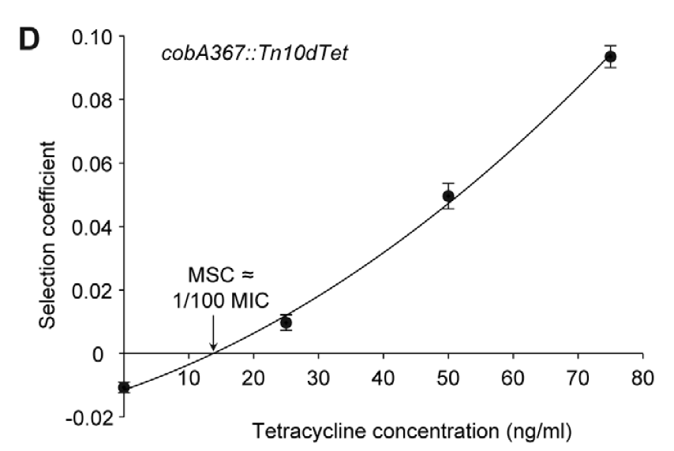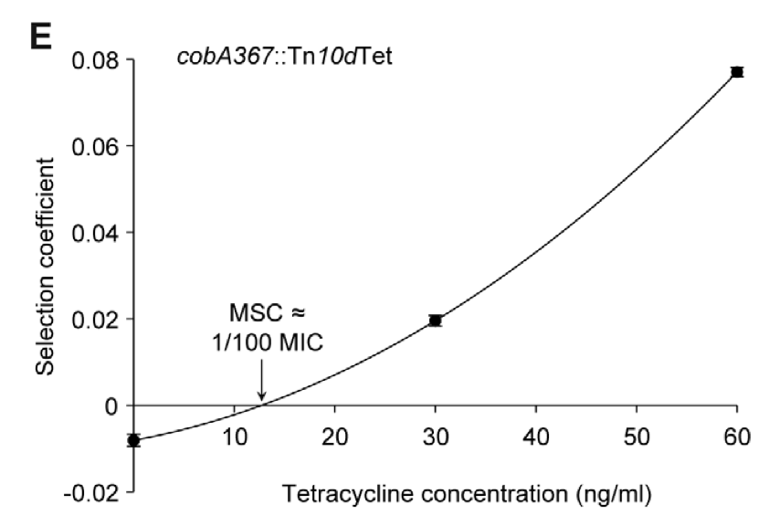

Chart 6D and 6E shows the competition experiments with low initial frequency of tetracycline with resistance markers Tn10dTet. Chart 6D are calculated from selection coefficients of up to 20 competition while 6E are calculated from selection coefficients of up to 24 competition. Both experiments have a low initial tetracycline concentration of 10-4, and we can observed the same selection coefficient of resistant mutants.

1. Ecological recycling is the cycling of nutrients from the physical environment into living organisms.
2. Pharmacodynamics model isthe study of the biochemical and physiological effects of drugs on the body or on microorganisms or parasites within or on the body and the mechanisms of drug action and the relationship between drug concentration and effect.
3. Minimum Inhibitory Concentration (MIC) is the lowest concentration of an antimicrobial that will inhibit the visible growth of a microorganism after overnight incubation
4. Isogenic strains are similar to immortal clones of genetically identical individuals. The same genotype can be reproduced indefinitely. Isogenic strains have made a substantial contribution to biomedical research.
5. De novo is a term for any method that makes predictions about biological features using only a computational model without extrinsic comparison to existing data. In this context, it may be sometimes interchangeable with the Latin term ab initio, beginning, anew
6. Resistant Markers is a gene introduced into a cell, especially a bacterium or to cells in culture, that confers a trait suitable for artificial selection
7. **Treatment dosing regimen** - The schedule of doses of a therapeutic agent per unit of time, including: the time between doses (e.g., every 6 hours) or the time when the dose(s) are to be given (e.g., at 8 a.m. and 4 p.m. daily), and the amount of a medicine (e.g., number of capsules) to be given at each specific time.